Sales Data Analysis and Revenue Prediction Report

Tian Wang
Auckland, New Zealand

Abstract— The rapid growth of e-commerce has generated large volumes of transaction data, creating opportunities for businesses to improve decision-making through data analysis. This study applies a complete data science workflow to analyse an electronic retail sales dataset and investigate sales patterns, customer purchasing behaviour, and product relationships. Data preprocessing, exploratory data analysis (EDA), statistical analysis, market basket analysis, and machine learning techniques were performed to address the research objectives. The results show that sales performance varies throughout the months, cities, products, and purchasing hours. Pearson correlation analysis indicates a moderate negative relationship between product price and sales quantity. Association rule mining identifies strong purchasing relationships between smartphones and compatible charging accessories, providing valuable insights for cross-selling strategies. Two machine learning models, Linear Regression and Random Forest, were developed to predict sales revenue. The Random Forest model achieved superior predictive performance, while feature importance analysis identified Price Each as the most influential predictor. Overall, the findings demonstrate that data science techniques can effectively extract meaningful business insights from e-commerce transaction data and support sales forecasting, pricing decisions, inventory management, and marketing strategies.
Keywords— E-commerce, Data Science, Exploratory Data Analysis, Market Basket Analysis, Machine Learning, Random Forest, Sales Prediction

Introduction of E-Commerce Background
The rise of E-commerce has been driven by the combined development of economy, technology and consumer behavior’s change [1]. Traditional offline retails is limited by geographical limits, intermediaries and high operating costs [2]. The adoption of the internet, smartphones, third-party payment services, modern supply chain systems, cloud computing and big data technologies has enabled businesses to store and process massive commercial data efficiently [3]. As online shopping has become the dominant forms of consumer purchasing, e-commerce platforms continuously generate massive transactions and user behavior data [4]. By analysing those data, companies can identify high-performing products, understand seasonal demand, optimise inventory management, determine the best marketing timing, and improve cross-selling strategies. In this case, data-driven decision making enables businesses to improve operational efficiency and increase profitability [5].

1.1 Project Ojective
In this project, a real-world e-commerce retail sales dataset is analysed using various data science techniques, including exploratory data analysis (EDA), statistical analysis, market basket analysis, and machine learning (Liner and random forest regression). The objective is to identify meaningful sales patterns and evaluate the effectiveness of predictive models for sales revenue estimation.

1.2 Research Questions
Based on the project objectives, the following research questions were formulated to guide the analysis:
- Which month generates the highest revenue?
- Which city contributes the most sales?
- Which products have the highest quantity sold and revenue contribution?
- What time of day has the highest order activity?
- Are expensive products sold less frequently?
- Which products are frequently purchased together?
- Can machine learning models predict sales revenue accurately?
- Which features are most important in predicting sales?

Dataset Understanding and Preprocessing

Dataset Description
The dataset used for this project is Sales Data.csv. It collects online purchase transaction records from an electronic retail company. The whole dataset includes 185,950 records and 11 variables. The transaction records ranges from 1st January 2019 to 1st January 2020, covering a full year of sales activities. It provides sufficient information to analyse seasonal trends, customer purchase behavior, product performance and sales patterns.

Each row represents a purchased product within an order and contains information such as the product name, quantity ordered, unit price, purchase date and time, purchase address, city, sales revenue, purchase month and hour. These variables provide both numberical and categorical information for exploratory data analysis and machine learning modelling.

Data Preprocessing
Before analysis, several preprocessing steps has been undertaken to improve the data quality.

Firstly, removed unnecessary column: Unnamed: 0. Because it only contains index values and did not provide any useful information for the analysis. Then checked missing values throughout the dataset, no missing values were found. Also, identify the duplicate records is the next step, removed 264 duplicated rows to ensure data consistency.

Afterwards, the order data variable was converted from text format to the datetime data type for time-based analysis. Additional features, including day and weekday, were extracted from the order date. Then, categorical variables such as product and city were transformed into numerical variables by using one-hot encoding before machine learning modelling. (Figure 1: Summary of Dataset)

exploratory data analysis(eda)
EDA was conducted to understand the characteristics of the sales dataset and identify important sales patterns, trends and relationships. A series of visualisations and statistic summaries were generated to answer the research questions related to sales performance, customer purchasing behavior and product characeristics.

Q1: Which month generates the highest revenue?
Figure 1 illustrates the monthly sales revenue during the period. Sales revenue gradually increased throughout the year and reached peak in December, January recorded the lowest revenue. The higher sales observed in the final quarter of the year which probably associated with the holiday promotions, seasonal shopping events (Black Friday, Xmas, Boxing Day etc.) and increased consumer spending.

Q2: Which city contributes the most sales?
Figure 2 shows the total sales revenue generated by different cities. San Francisco recorded the highest sales revenue, while Los Angeles and New York City followed. This suggests that cities with larger populations and stronger economic activity contributed more to overall sales.

Q3: Which products have the highest quantity sold and revenue contribution?
Figure 3 : Quantity Sold
Figure 4: Revenue by Product

Product performance was evaluated based on both sales quantities and sales revenue. The analysis shows that low=priced accessories, such as charging cables and batteries, gained the highest sales volumes. In contrast, premium electronics products, like laptops and smartphones, generated higher sales revenue regardless of lower purchase frequency. This points out that sales quantity and revenue contribution do not necessarily follow the same pattern.

Q4: What time of day has the highest order activity?

Figure 5 The bar chart shows that order activity gradually increased throughout the day and reached its highest level at 19:00 (7 PM). Order volumes remained relatively high between 11:00 AM and 9:00 PM, while very few orders were placed during the early morning hours (2:00 AM to 5:00 AM). This suggests that customers were more likely to shop during the afternoon and evening, possibly after work or school.

Q5: Are expensive products sold less frequently?

The scatter plot Figure 6 shows a moderate negative relationship between product price and total quantity sold. The correlation coefficient is -0.601, indicating that products with higher prices generally have lower sales volumes.
Low-priced products such as AAA Batteries, AA Batteries and charging cables recorded the highest quantities sold, while expensive products tended to sell fewer units. However, some high-priced products, such as the MacBook Pro Laptop, still achieved relatively strong sales, indicating that factors other than price also influence customer purchasing behaviour.
Overall, the analysis suggests that more expensive products are generally sold less frequently, although the relationship is not perfect.

Overall, EDA identified several important sales patterns.

Sales varied across the cities

Purchase behavior changed throughout the day

Product revenue differed from sales quantity

Product price showed a moderate negative relationship with sales volume.

Cities difference is a value finding for marketing segmentation, purchase hour behaviour helps the company to decide the marketing time, also the product selection can be considered when launching marketing campaign for product promotion.

The findings from EDA provides the foundation for the subsequent statistical analysis, market basket analysis and machine learning modelling.

Statistical Analysis

4.1 Pearson Correlation Analysis
To discover the relationship between product price and sales quantity, Pearson correlation analysis has been conducted. Pearson’s correlation coefficient is commonly used to measure the strength and direction of a linear relationship between two continuous variables [6]. In this project, the analysis was performed using the average product price and the total quantity sold for each product.

However, the calculated Pearson correlation coefficient was -0.601, indicating a moderate negative correlation between product price and quantity sold. This negative relationship is consistent with consumer purchase behaviour in the retail industry. Lower-priced products, such as charging cables and batteries, are relatively cheaper and frequently purchased, resulting a high sales volumes, also they are consumable products, the lifetime for this type of products also determines the frequency. On the other hand, premium products including laptops and smartphones are purchased less frequently but generate higher revenue. These findings may help businesses optimize pricing strategies, inventory planning and promotional activities.

association rule/market basket analysis

Market Basket Analysis
Q6: Which products are frequently purchased together? (Tabel 2)

Market Basket Analysis was performed to identify which products are frequently purchased together within the same customer order. The Apriori algorithm was applied to discover frequent itemsets, while association rules were generated to identify relationships between products. Three commonly used evaluation metrics, support, confidence and life were used to assess the strength of each association rule.

Frequent itemsets
The frequent itemsets indicates that charging accessories and smartphones appeared most frequently in the transactions. Procuts such as USB-C Charging Cable, lighting charging cable and iPhone showed the highest support values, indicating those products were purchased in a large proportion of the overall orders.

Association Rules
According to the table, the association rules reveal strong purchasing relationship between smartphones and the charging accessories. For example, customers who purchased an iPhone also purchased a lighting charging cable with a confidence of 54.2% and a life value of 2.159. Likewise, customers purchasing a Google phone were highly likely to purchase a USB-C charging cable with a confidence of 61.1% and a life value of 2.078.

These findings suggest that customers frequently purchase smartphones together with its accessories. The life values greater than 1 indicate positive associations between these products. This means the products are purchased together more often than expected by chance. The results provide useful insights for retailers to improve product bundling, cross-selling strategies, recommendation systems and promotional campaigns.

Machine learning modeling

6.1 Feature Selection and Data Preparation

To predict sales revenue, a supervised machine learning approach should be adopted. The target variable was sales, while the predictor variables includes Quanitiy ordered, price each, month, hour, product and city. Product and city are categorical variables and were transformed into numberical variables by using one-hot encoding before model training.

The dataset was then divided into training and testing dataset using an 70:30 split. The training dataset was used to build the prediction models, while the testing dataset was used to evaluate the performance. This approach helps assess how well the models generalise to unseen data.

6.2 Model Development

Two regression models were used in this project study: linear regression and random forest regression.

Linear regression
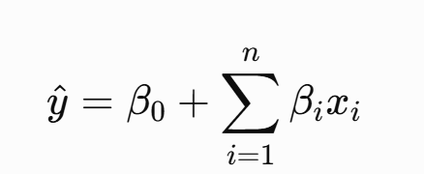

where y^ is the predicted sales revenue, β0​is the intercept, βi represents the regression coefficients, and Xi denotes the predictor variables.

Random Forest
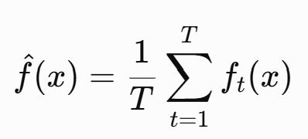

Where T is the number of decision trees and Ft(x) is the prediction generated by the t-th decision tree.

Linear Regression was selected as a baseline model because of its simplicity, while Random Forest regession was chosen because it can capture nonlinear relationships and interactions between variables through an ensemble of decision tress.

6.3 Model Evaluation

Model performance was evaluated using two commonly used regression metrics: the coefficients of detemination(R2) and the Root mean squared error (RMSE). The R2 score measures the proportion of variance in the target variable explained by the model, while RMSE measures the average prediction error. A higher R2 value and a lower RMSE indicate better predictive performance.

The Linear Regression model achieved an R² score of 0.9983 and an RMSE of 13.66, indicating excellent prediction accuracy. Although a few high-value transactions showed larger prediction errors, most predicted values closely followed the actual sales values. (Table 3 & Figure 7 & 8)

The Random Forest model further improved prediction performance, achieving an R² score of 1.0000 and an RMSE of 1.39. The predicted values almost completely overlapped with the actual values, demonstrating extremely high predictive accuracy on the testing dataset.

It should be noted that the high prediction accuracy is partly influenced by strong relationship between the selected predictor variables and target variables. Future studies could investigate more challenging prediction tasks by incorporating customer behaviour, promotional activtieis, and external market factors.

Featured importance analysis

Q8: Which features are most important in predicting sales?

Feature importance analysis was performed using the Random Forest model to determine the contribution of each feature to sales prediction. Random Forest estimates the relative importance of each predictor based on its contribution to reducing prediction error during model training.

As shown in Figure 9, Price Each was the most important feature, with an importance score of approximately 0.85, indicating that product price plays the dominant role in predicting sales revenue. Product-related variables, particularly MacBook Pro Laptop and ThinkPad Laptop, also contributed to the model, although their importance was substantially lower than that of product price.

Practical Implications

The results suggest that pricing is the key factor influencing sales prediction. Businesses can use pricing information to improve revenue forecasting and pricing strategies. Although product categories provide some additional predictive value, time-related and location-related variables have relatively little impact in this dataset.

Discussion
This project successfully applied a complete data science workflow to analyse an e-commerce sales dataset. The EDA part revealed clear sales patterns across months, cities, products and purchasing hours. Staticial analysis further confirmed a moderated negative relationship between product price and quantity sold, indicating lower-priced products achieve higher sales volume.
The market basket analysis identify the strong purchasing relationships between smartphones and its accessories. This findings provide valuable insights for product recommendation systems and promotional campaigns.

The machine learning model achieved excellent predictive performance. The feature importance analysis demonstrated that price each was the dominant predictor of sales revenue.

Based on those findings, businesses can improve inventory planning optimize pricing strategies, schedule promotional activities during peak sales periods and conducting product combo strategies to increase sales performance.

conclusion

This project applied data science techniques to analyse anelectronic retail sales dataset and investigate important sales patterns customer purchasing behavior and product relationships. Exploratory data analysis, statistical analysis, market basket analysis and machine learning were successfully implemented to answer the research questions.

The results showed that sales varied across different months and cities, product price was negatively associated with sales quanitiy, and smartphone were frequently purchased together with charging accessories. Among the machine learning models, Random forest achieved the highest prediction accuracy and identified Price Each as the most influential feature for predicting sales revenue.

This study has several limitations. The dataset covers only one year of sales transactions and does not include customer demographic information, promotional activities, or seasonal events that may influence purchasing behaviour. Additionally, the target variable sales is directly related to Price Each and Quantity Ordered, making the prediction task relatively straightforward.

However, future research could incorporate additional customer and marketing variables, analysie multi-year transaction data and explore more advanced machine learning techniques to improve predition performance for a deeper business insights.

References

- Krisna, A. M. (2025). E-Commerce and Digital Economy: An Analysis of Changing Consumption Patterns and Their Impact on Economic Growth. Oikonomia: Journal of Management Economics and Accounting, 2(3), 123-137.
- Lieber, E., & Syverson, C. (2012). Online versus offline competition. The Oxford handbook of the digital economy, 189, 1-29.
- Rejeb, A., Keogh, J. G., & Treiblmaier, H. (2019). Leveraging the internet of things and blockchain technology in supply chain management. Future Internet, 11(7), 161.
- Wigayha, C. K., Rolando, B., & Wijaya, A. J. (2025). A demographic analysis of consumer behavioral patterns on digital e-commerce platforms. JUMDER: Jurnal Bisnis Digital Dan Ekonomi Kreatif, 1(2), 22-37.
- Naveeenkumar, N., Rallapalli, S., Sasikala, K., Priya, P. V., Husain, J., & Boopathi, S. (2024). Enhancing consumer behavior and experience through AI-driven insights optimization. In AI impacts in digital consumer behavior (pp. 1-35). IGI Global Scientific Publishing.
- Schober, P., Boer, C., & Schwarte, L. A. (2018). Correlation coefficients: appropriate use and interpretation. Anesthesia & analgesia, 126(5), 1763-1768.

Appendix

Table 1: Summary of Dataset
Items | Values
Records | 185,950
Variables | 11
Time Period | 1/1/2019 to 1/1/2020
Missing Values | 0
Duplicate Rows Removed | 264
Target Variable | Sales

Figure 1:
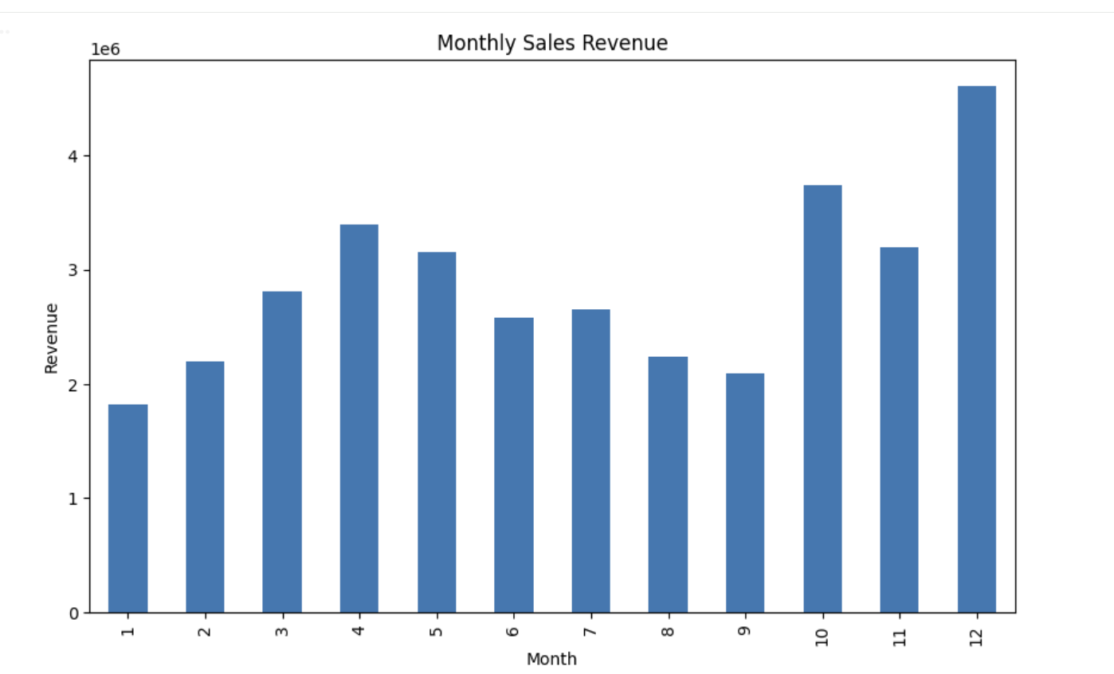

Figure 2
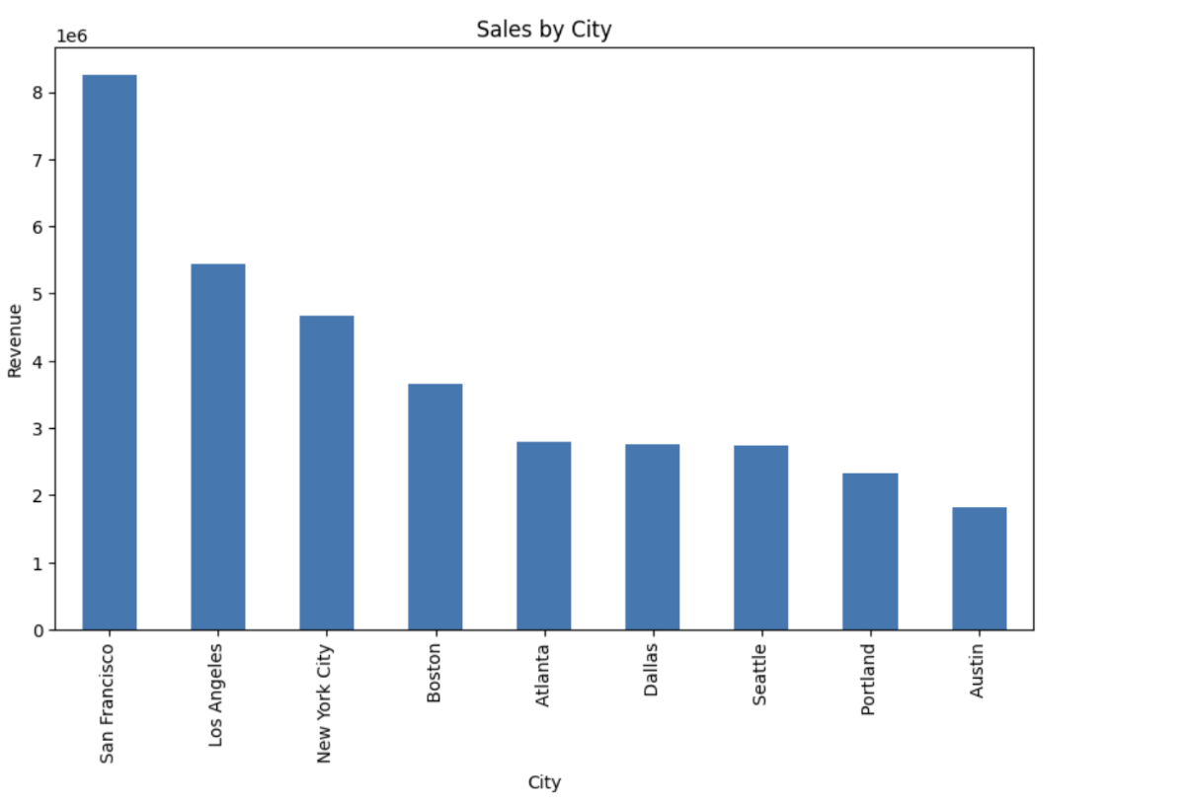

Figure 3

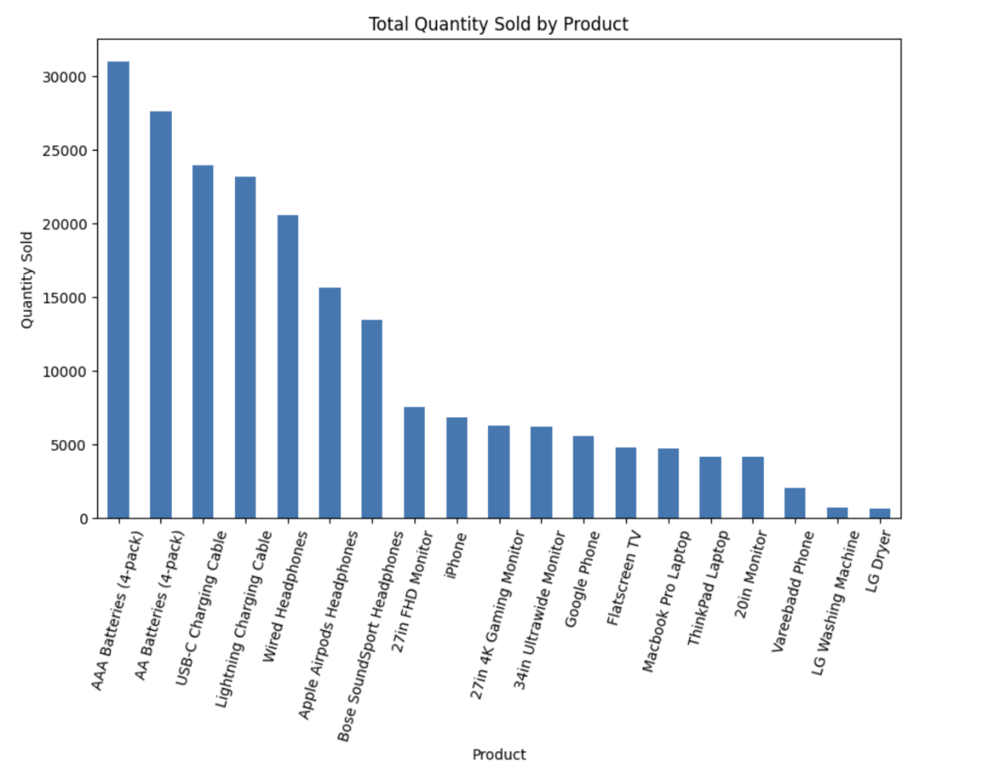

Figure 4
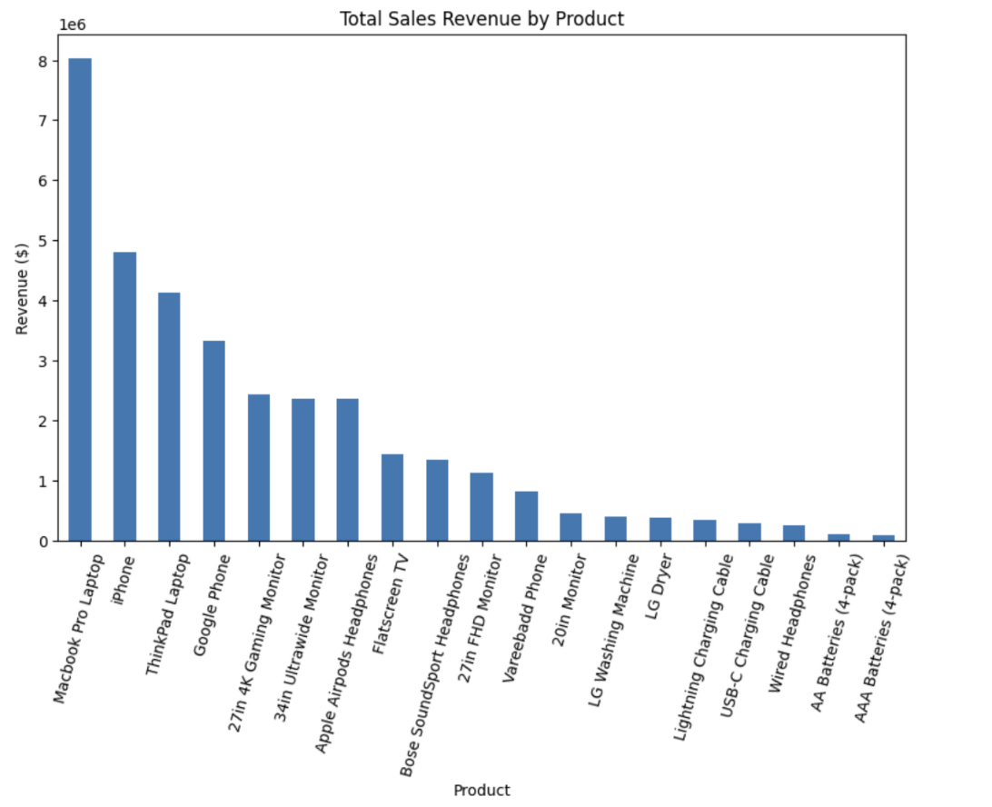

Figure 5

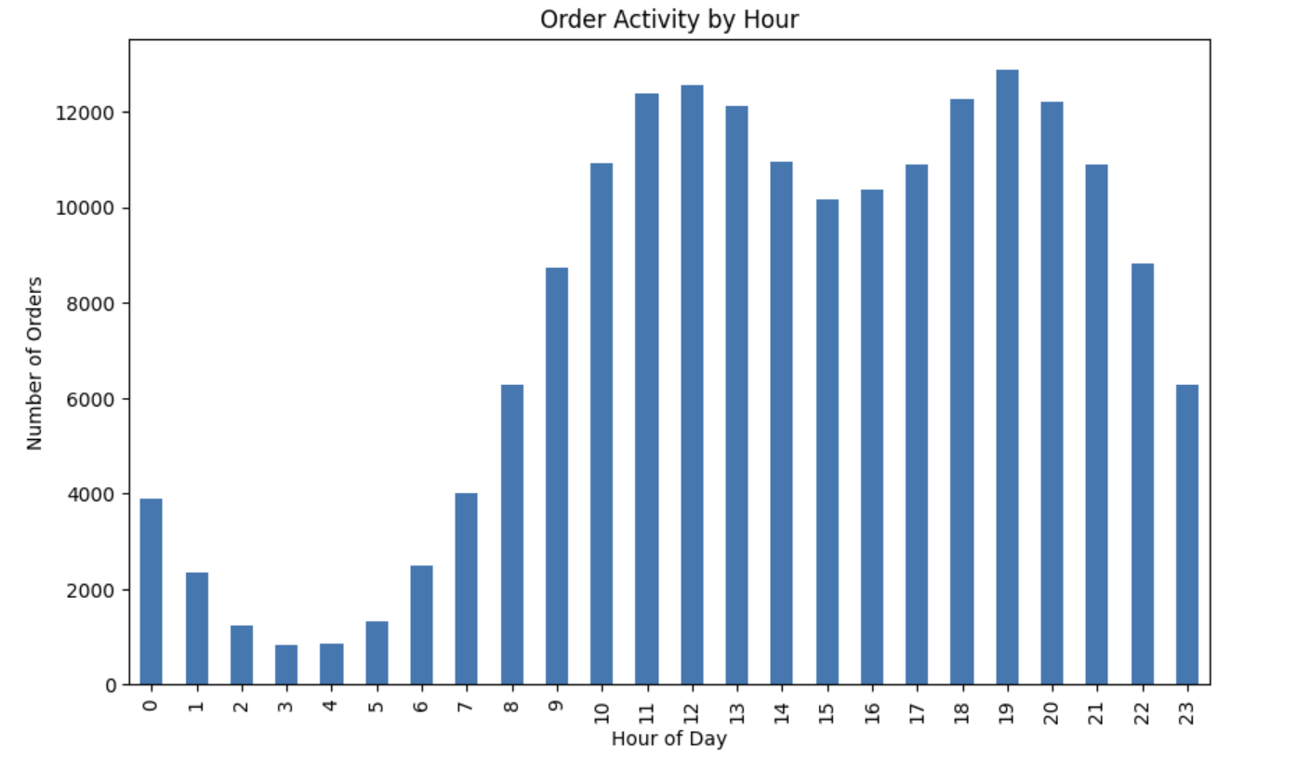
Figure 6

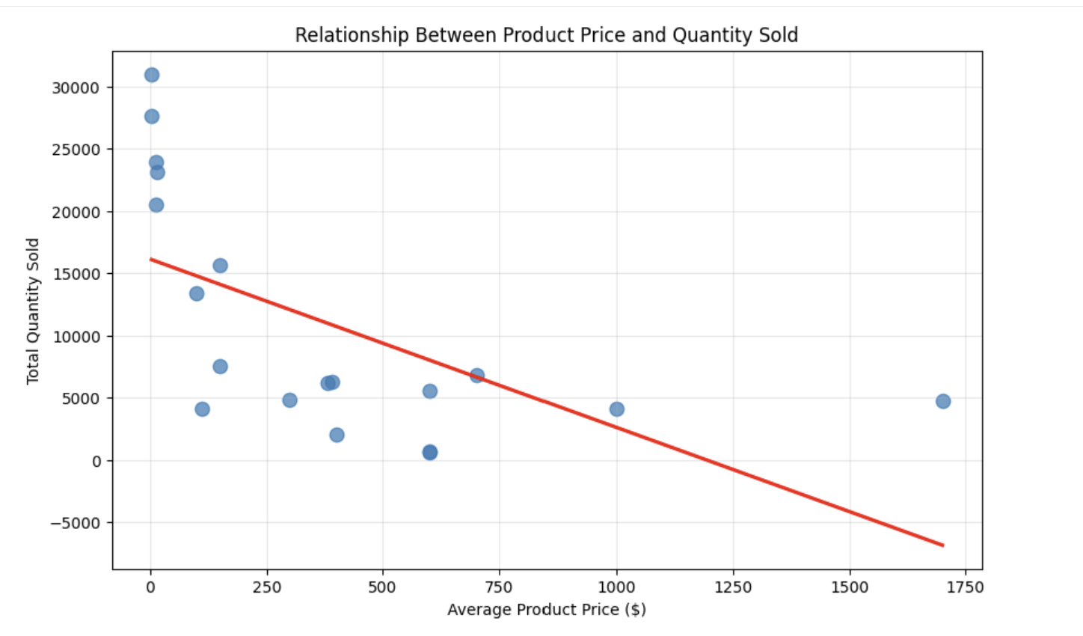

Table 2

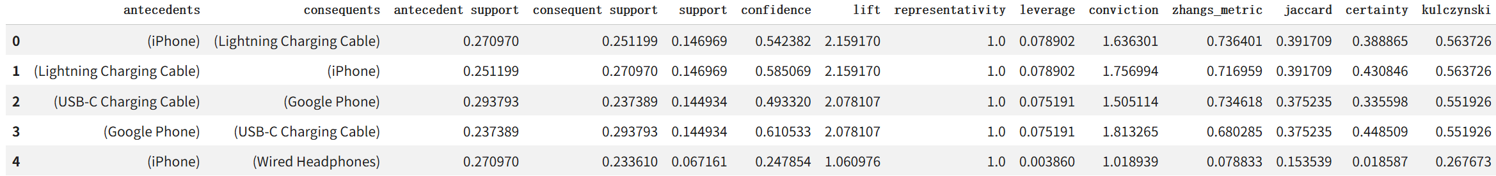

Table 3

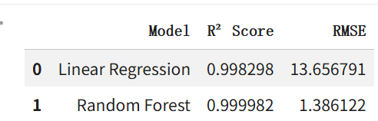

Figure 7

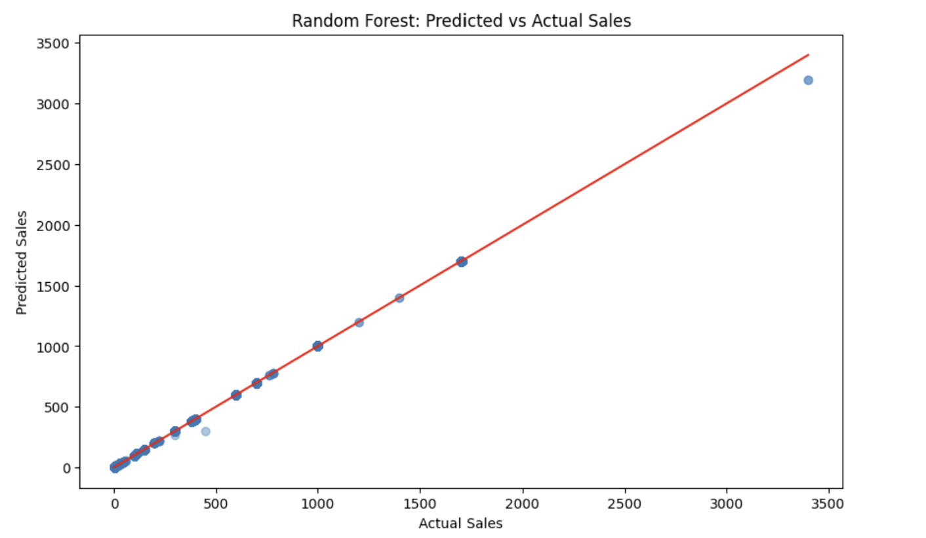
Figure 8

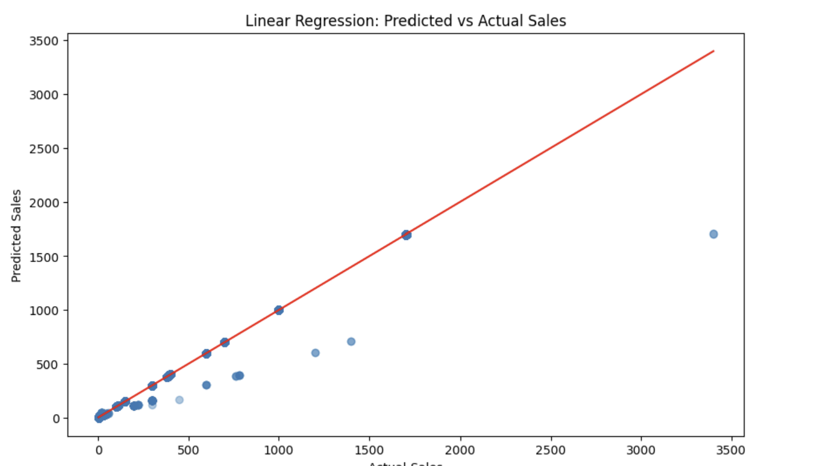

Figure 9
